Waco-McLennan County Public Health District

225 W. Waco Drive, Waco, Texas 76707
Phone 254-750-5429
Fax 254-750-5452

kellyc@wacotx.gov

Serving the cities of Bellmead, Beverly Hills, Bruceville-Eddy, Crawford, Gholson, Golinda, Hallsburg, Hewitt, Lacy Lakeview, Leroy, Lorena, Mart, McGregor, Moody, Riesel, Robinson, Ross, Waco, West, Woodway, and all areas of McLennan County.

Waco-McLennan County Public Health District Announces
- 178 New Cases of COVID-19
- No New Deaths Attributed to COVID-19
- Next TWO days free testing locations

(November 13, 2020) One hundred and seventy-eight new cases of COVID-19 are confirmed as of today. Eighty-five of the cases are reported from surge testing. The total number of cases to date is 11,956. There are 1,138 estimated active cases, and 10,650 estimated cases who have recovered. Sixty-six cases are hospitalized. Of the 66 hospitalized, 49 cases are McLennan County residents. Twelve are on ventilators. The total number of deaths is 168.

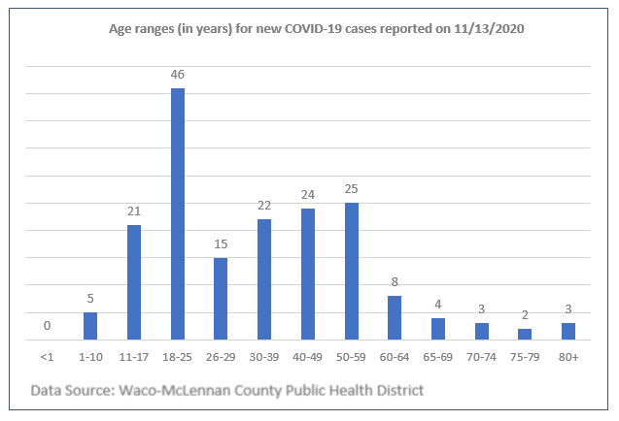

--more--

As of November 12, 2020, the hospitalization rate is 12.07% for Trauma Service Area M, as calculated by Texas Department of State Health Services (DSHS).

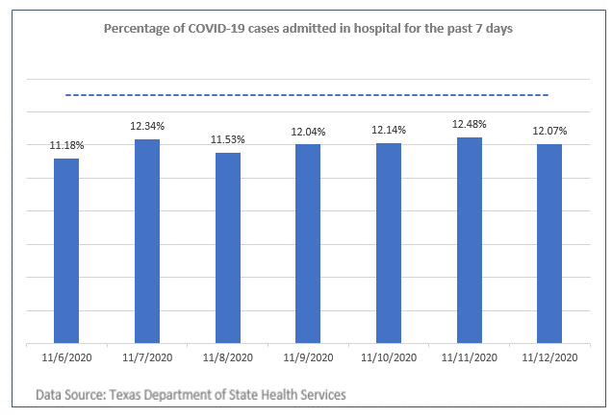

Executive Order GA-32 allows restaurants and other venues to reopen at 75% capacity and allows elective surgeries if the hospitalization rate in a Trauma Service Areas (TSA) with a COVID-19 hospitalizations rate under 15% over a seven-day period. If the hospitalization rate goes over 15% for seven consecutive days, venue capacity will be lowered to 50% and elective surgeries will be postponed until further notice.

COVID-19 Website:
For additional expanded information including age, race, ethnicity, gender, ICU bed availability and more, please visit www.covidwaco.com or www.mclennancountycovid.com

--more--

Free COVID-19 Testing Site Update
Register at www.covidwaco.com
All testing sites are using the saliva-based test.

Saturday, November 14
NOTE: ALL TESTS ARE SALIVA TESTS. PLEASE DO NOT EAT, DRINK, or BRUSH YOUR TEETH FOR 1/2 HOUR PRIOR TO THE TEST.
All locations are open 9 am-6 pm unless otherwise noted.
Sacred Heart Catholic Church
2621 Bagby Avenue
Drive-through Clinic
Antioch Church
505 N 20th St
Drive-through Clinic

Sunday, November 15
NOTE: ALL TESTS ARE SALIVA TESTS. PLEASE DO NOT EAT, DRINK, or BRUSH YOUR TEETH FOR 1/2 HOUR PRIOR TO THE TEST.
All locations are open 9 am-6 pm unless otherwise noted.
Antioch Church
505 N 20th St
Drive-through Clinic

We will update this page each day to include no more than the NEXT TWO DAYS of testing locations so you can mention at least one during your daily COVID-19 updates. A list of ALL scheduled testing can be found at COVIDWACO.COM

###

